Attack Simulation
Machine Link: https://www.hacksmarter.org/courses/63bc86e1-3ab3-43be-b32e-62a676e6dee7

Steps:
Start with an anonymous session connect to smb.
Here I discover write access on a share.
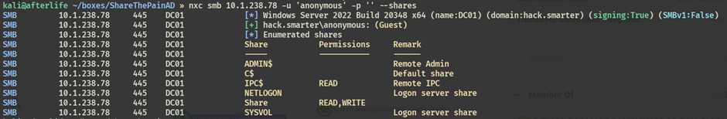

From here I used slinky module for netexec to drop a lnk file which will force users visiting the share to authenticate with my machine and this way I will be able to capture the user's hashes.

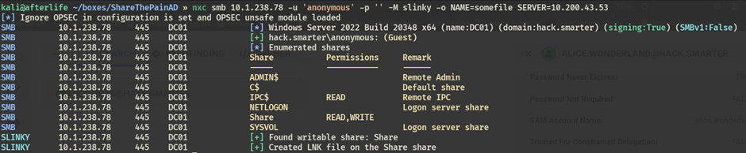

Started Responder on my machine with the following command
- sudo responder -I tun0

I was able to capture hash of user bob.ross
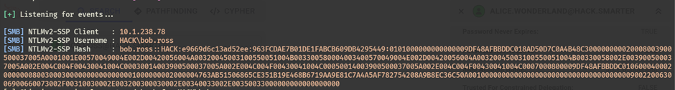

This hash can further be cracked or relayed to another machine.

